

# LAB 03 ALGORITHM

# ALGORITHM

The word **Algorithm** means "a process or set of rules to be followed in problem-solving operations". Therefore, Algorithm refers to a set of rules or instructions that step-by-step define how a work is to be executed upon in-order to get the expected results.

**PRACTICE PROBLEMS**

1. Write a pseudo code that calculates the Greatest of 3 numbers.

2. Write pseudo code that reads three numbers and writes them all in sorted order.

3. Write pseudo code that Calculate the average of the five numbers

# LAB TASK

1. Write a pseudo code to enter a number represents a person age then display the following on a message boxes:

1. "Wrong age" if the age less than or equal to 0 years.

2. "Child" if the age less than 8 years.

3. "Boy" if the age greater than or equal to 8 years.

4. "Young" if the age greater than or equal to 18 years.

5. "Old" if the age greater than or equal to 35 years.

6. "Very Old" if the age greater than or equal to 65 years

1. Write pseudo code for this: "input 3 side of a triangle and figure out if it’s scalene, isosceles, equilateral or right-angle triangle”.

# Your First CPP program.

## Exercise 1: A Simple First Program

You need to perform the following to complete the task.

1. Open the Terminal (Ctrl + Alt + t)
2. Installation g++ lab@lab-OptiPlex-330:~$ **sudo apt install g++**

Note: g++ is already install on lab PCs

1. Create file of .cpp file extension using touch command ~$ **touch helloworld.cpp**

1. Now open the text editor using gedit command ~$ **gedit helloworld.cpp**

5. Write the following code in helloworld.cpp file.

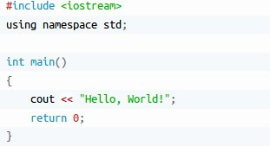

1. Save and close the file.
2. compile and execute it

~$ g++ -o hello helloworld.cpp

~$./hello